1.
SELECT student.name, student.surname, city.cityname FROM student
JOIN city ON city.cityID = student.cityID;
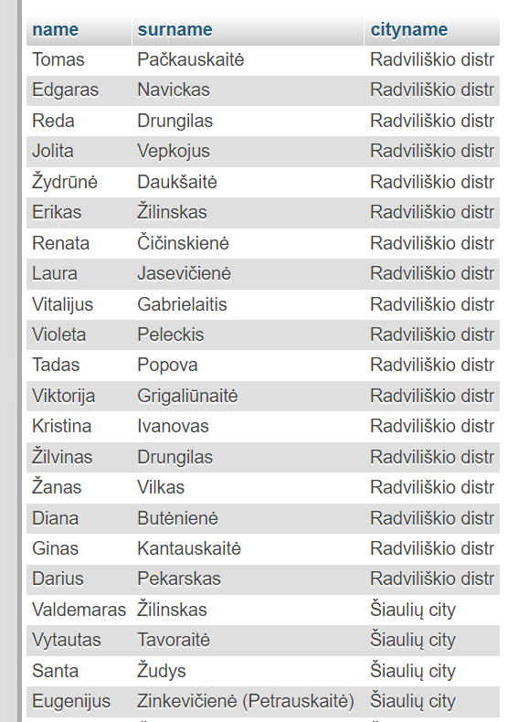
2.
SELECT student.name, student.surname, groups.groupname FROM student
JOIN groups ON groups.groupID = student.groupID
WHERE groups.groupname LIKE 'KTn%';
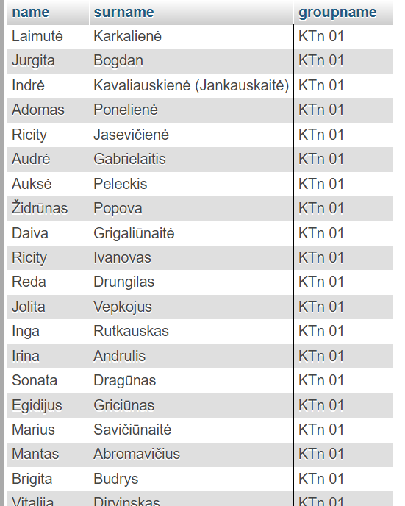
3.
SELECT city.cityname, COUNT(id) AS students FROM student
JOIN city ON city.cityID = student.cityID GROUP BY city.cityname;
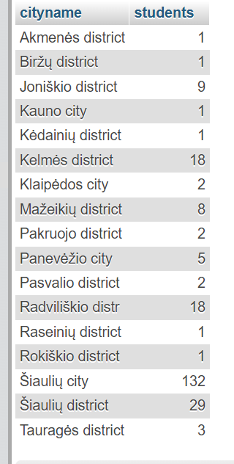
4.
SELECT groups.groupname, status.statusname,
COUNT(student.id) AS students FROM student
JOIN groups ON groups.groupID = student.groupID
JOIN status ON status.statusID = student.statusID
WHERE status.statusname = 'Active'
GROUP BY groups.groupname;
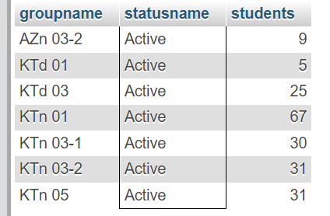6.
5.
SELECT groups.groupname, COUNT(student.id) AS students
FROM student JOIN groups ON groups.groupID = student.groupID
GROUP BY groups.groupname
ORDER BY groups.groupname DESC LIMIT 3;
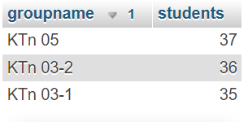
6.
SELECT city.cityname, student.name,
COUNT(student.name) AS name_count FROM student
JOIN city ON city.cityID = student.cityID
GROUP BY student.name
HAVING COUNT(student.name) > 1
ORDER BY city.cityname;
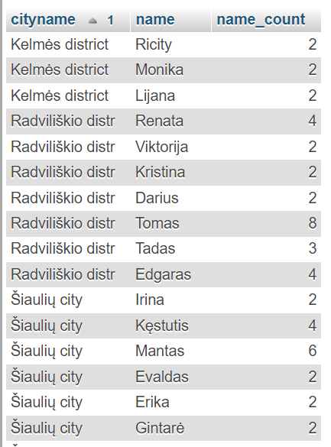
7.
UPDATE student JOIN groups ON groups.groupID = student.groupID
JOIN status ON status.statusID = student.statusID
SET student.statusID = 6
WHERE status.statusname = 'Active' AND groups.groupname = 'KTd 03';
For checking:
SELECT groups.groupname, status.statusname,
COUNT(student.id) AS student_count FROM student
JOIN groups ON groups.groupID = student.groupID
JOIN status ON status.statusID = student.statusID
WHERE groups.groupname = 'KTd 03'
GROUP BY groups.groupname;
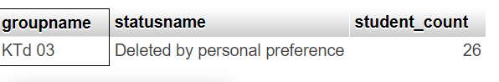

8.
SELECT COUNT(student.id) AS student_count FROM student
JOIN city ON city.cityID = student.cityID
WHERE city.cityname LIKE '%city'
UNION
SELECT COUNT(student.id) AS student_count FROM student
JOIN city ON city.cityID = student.cityID
WHERE city.cityname LIKE '%distr';
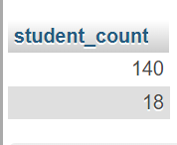
9. Change foreign key to CASCADE on update.
DELETE FROM student
WHERE statusID = (SELECT statusID FROM status
WHERE statusname = 'holidays');
10. Foreign key SET NULL ON DELETE and CASCADE ON UPDATE
DELETE FROM city WHERE cityname = 'Šiaulių city';

SELECT student.name, student.surname, city.cityname FROM student
LEFT JOIN city ON student.cityID = city.cityID
ORDER BY ISNULL(student.cityID), student.Name;
